1. **PT**: Performance Testing.
2. **NFR**: Non-Functional Requirement.
3. **Response/Transaction Time**: The time taken by the system to respond to a specific request.
4. **Think Time**:  
   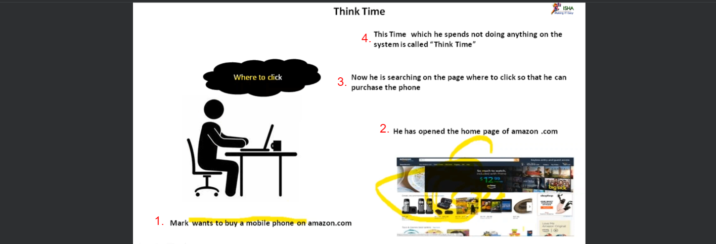

So, there is difference b/w think time and transaction time.

|  |  |
| --- | --- |
| **Response Time** | Time taken by a server. |
| **Transaction/Response Time** | Time taken by an end user. |

1. **LR**: Load Runner.
2. **Throughput**: Transactions Per Second or Bytes Per Second.  
   We will discuss about it later on.